SQL project results
Total loan Application
SELECT
count (id) AS Total_loan_Application from Bank_loan_data
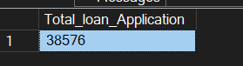
PMT Loan Application
SELECT count (id) AS PMTD_Total_loan_Applications from Bank_loan_data
WHERE Month (issue_date) =11 and year (issue_date) =2021
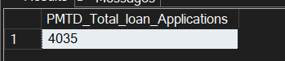
MTD Total loan Application
SELECT count (id) AS MTD_Total_loan_Applications from Bank_loan_data
WHERE Month (issue_date) =12 and year (issue_date) =2021
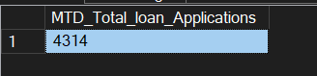
Total Funded Amount
SELECT sum (loan_amount) AS Total_funded_amount from Bank_loan_data
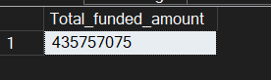
MTD Total Funded Amount
SELECT sum (loan_amount) AS MTD_Total_funded_amount from Bank_loan_data
WHERE month (issue_date) =12 and year(issue_date) = 2021
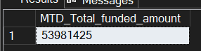

PMT Total Funded Amount
SELECT sum (loan_amount) AS PTD_Total_funded_amount from Bank_loan_data
WHERE month (issue_date) =11 and year(issue_date) = 2021
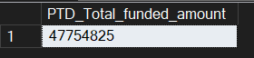
Total Amount Received
SELECT sum (total_payment) AS Total_Amount_Received FROM Bank_loan_data
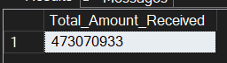
Total Amount Received
SELECT sum (total_payment) AS Total_Amount_Received FROM Bank_loan_data
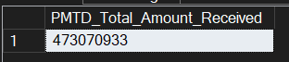
MTD_Total_Amount_Received
SELECT sum (total_payment) AS MTD_Total_Amount_Received FROM Bank_loan_data
Where month (issue_date) = 12 and year(issue_date) =2021
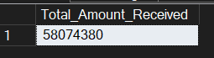
PMTD_Total_Amount_Received
SELECT sum (total_payment) AS PMTD_Total_Amount_Received FROM Bank_loan_data
Where month (issue_date) = 11 and year(issue_date) =2021
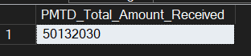
AVG_Interest_Rate
SELECT ROUND (AVG (int_rate),4)*100 AS AVG_Interest_Rate from Bank_loan_data
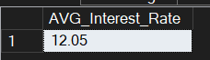
MTD_AVG_Interest_Rate
SELECT ROUND (AVG (int_rate),4)*100 AS MTD_AVG_Interest_Rate from Bank_loan_data
WHERE Month (issue_date) =12 AND year (issue_date)=2021
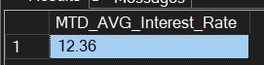
PMTD_AVG_Interest_Rate
SELECT ROUND (AVG (int_rate),4)*100 AS PMTD_AVG_Interest_Rate from Bank_loan_data
WHERE Month (issue_date) =11 AND year (issue_date)=2021
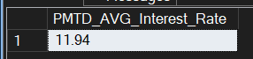
AVG_DTI
SELECT ROUND (Avg(dti),4)*100 AS AVG_DTI FROM Bank_loan_data
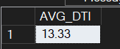
MTD_AVG_DTI
SELECT ROUND (Avg(dti),4)*100 AS MTD_AVG_DTI FROM Bank_loan_data
WHERE month (issue_date) =12 AND year (issue_date)=2021
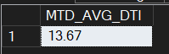
PMTD_AVG_DTI
SELECT ROUND (Avg(dti),4)*100 AS PMTD_AVG_DTI FROM Bank_loan_data
WHERE month (issue_date) =11 AND year (issue_date)=2021
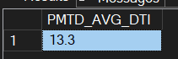

Good_Loan_Percentage
SELECT
(COUNT(CASE when loan_status = 'Fully paid' OR loan_status = 'Current' THEN id END)*100)
/
Count (id) AS Good_Loan_Percentage
FROM Bank_loan_data
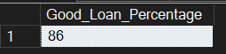
Good_Loan_Application
SELECT COUNt (id) AS Good_Loan_Application FROM Bank_loan_data
WHERE Loan_status = 'Fully paid' OR Loan_status = 'Current'
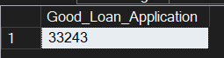
Good_Loan_Funded_Amount
SELECT sum (loan_amount) AS Good_Loan_Funded_Amount FROM Bank_loan_data
WHERE Loan_status = 'Fully paid' OR Loan_status = 'Current'
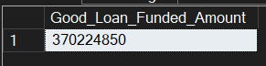
Good_Loan_Received_Amount
SELECT SUM(total_payment) AS Good_Loan_Received_Amount FROM Bank_loan_data
WHERE Loan_status = 'Fully paid' OR Loan_status = 'Current'
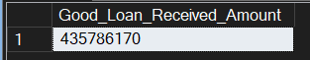
Bad_Loan_Percentage
SELECT (count(CASE when loan_status = 'Charged off' then id END)*100.0)
/
count (id) AS Bad_Loan_Percentage
FROM Bank_loan_data
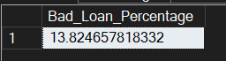
Bad_Loan_Applications
SELECT COUNT (id) AS Bad_Loan_Applications from Bank_loan_data
Where loan_status='Charged off'
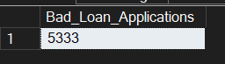
Bad_Loan_Funded_Amount
SELECT SUM (loan_amount) AS Bad_Loan_Funded_Amount from Bank_loan_data
Where loan_status='Charged off'
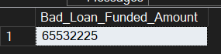
Bad_Loan_Amount_Received
SELECT SUM (total_payment) AS Bad_Loan_Amount_Received from Bank_loan_data
Where loan_status='Charged off'
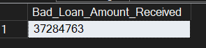
loan_status
SELECT loan_status,
count (id) AS Total_Loan_Applications,
SUM (total_payment) AS Total_Amount_Received,
SUM (loan_amount) AS Total_Funded_Amount,
AVG (int_rate*100) AS Interest_Rate,
AVG (dti*100) AS DTI
FROM
Bank_loan_data
Group by
loan_status
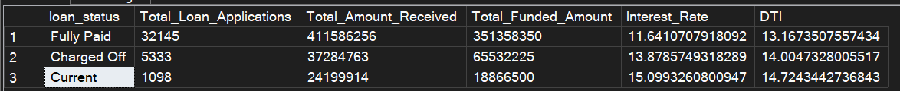
MTD loan status
SELECT
loan_status,
SUM (total_payment) AS MTD_Total_Amount_Received,
SUM(loan_amount) AS MTD_Total_Funded_Amount
FROM
Bank_loan_data
WHERE
month (issue_date) = 12
GROUP BY
loan_status
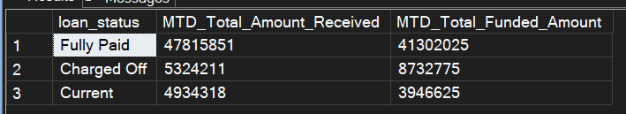
MONTH
SELECT
Month(issue_date) AS Month_Number,
DATENAME(Month, issue_date) AS Month_Name,
Count(id) AS Total_Loan_Applications,
SUM (loan_amount) AS Total_funded_Amount,
SUM(total_payment) AS Total_Rceeived_Amount
From Bank_loan_data
GROUP BY Month(issue_date),DATENAME(Month,issue_date)
ORDER BY Month(issue_date)
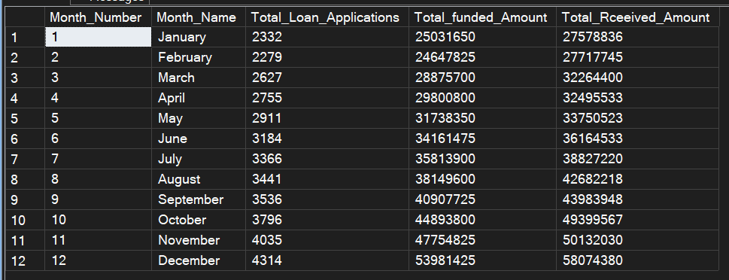
Regional analysis by state
SELECT
address_state,
Count(id) AS Total_Loan_Applications,
SUM (loan_amount) AS Total_funded_Amount,
SUM(total_payment) AS Total_Rceeived_Amount
From Bank_loan_data
GROUP BY address_state
ORDER BY Count(id) DESC
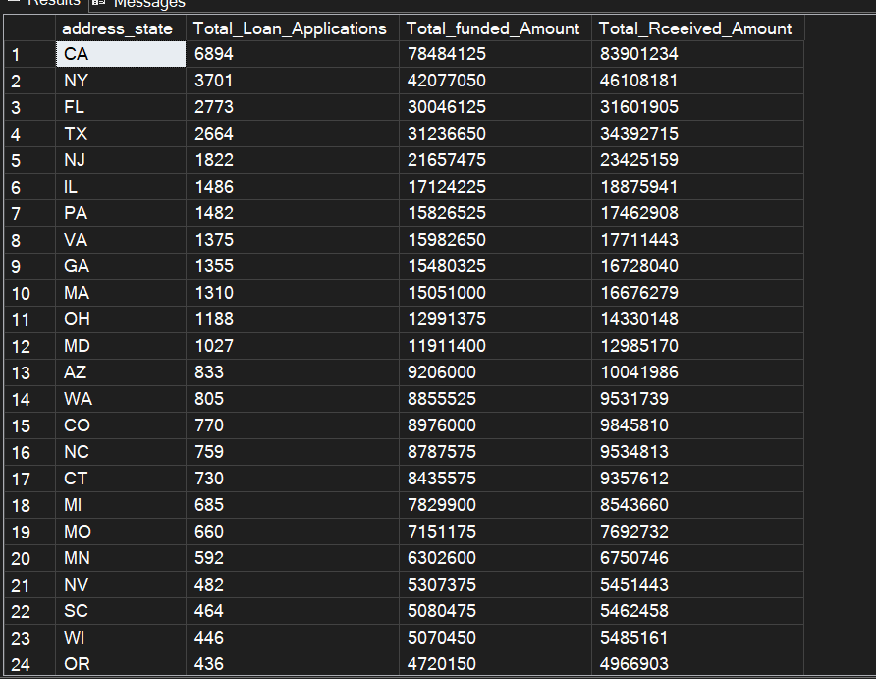
Loan term analysis
SELECT
term,
Count(id) AS Total_Loan_Applications,
SUM (loan_amount) AS Total_funded_Amount,
SUM(total_payment) AS Total_Rceeived_Amount
From Bank_loan_data
GROUP BY term
ORDER BY term
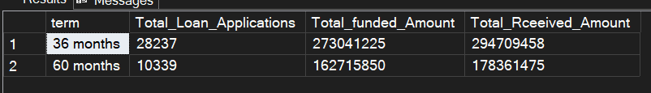
emp_length analysis
SELECT
emp_length,
Count(id) AS Total_Loan_Applications,
SUM (loan_amount) AS Total_funded_Amount,
SUM(total_payment) AS Total_Rceeived_Amount
From Bank_loan_data
GROUP BY emp_length
ORDER BY Count(id) desc
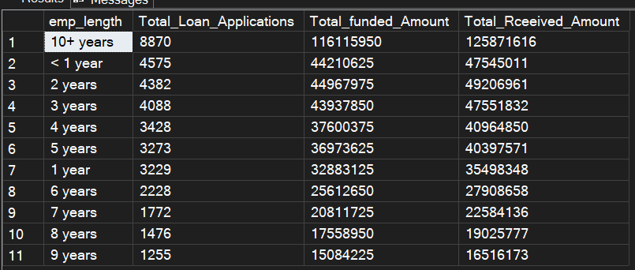
Loan purpose breakdown
SELECT
purpose,
Count(id) AS Total_Loan_Applications,
SUM (loan_amount) AS Total_funded_Amount,
SUM(total_payment) AS Total_Rceeived_Amount
From Bank_loan_data
GROUP BY purpose
ORDER BY Count(id) desc
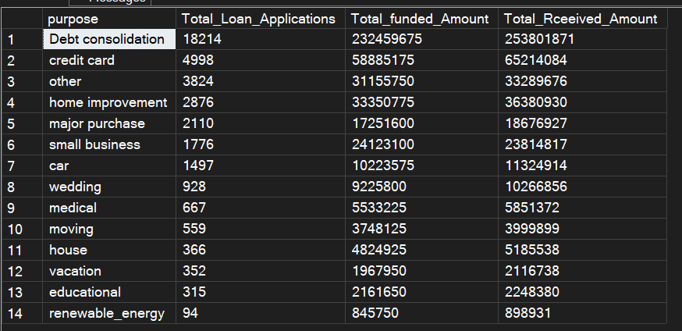
Home ownership Analysis
SELECT
home_ownership,
Count(id) AS Total_Loan_Applications,
SUM (loan_amount) AS Total_funded_Amount,
SUM(total_payment) AS Total_Rceeived_Amount
From Bank_loan_data
GROUP BY home_ownership
ORDER BY Count(id) desc
